score = int(input())

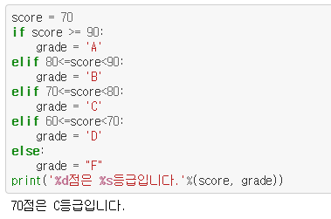

/ : 나누기

// : 몫

% : 나머지 🡺 나머지가 0이면 == 나누어 떨어짐

< 윤년이면 True인 조건 >

(year % 4 == 0) **and** (year % 100!=0) **or** (year % 400==0)

for **i** in range(1, 6): # i : 1~5

for **j** in range(i): # j : **0**~i-1

print('*', end = "\n",) #end = 개행 대신 “”

print() #개행(enter)

|  |  |  |  |  |  |  |
| --- | --- | --- | --- | --- | --- | --- |
| i (range(i) | j |  |  |  |  |  |
| range(1) | 0* |  |  |  |  |  |
| range(2) | 0* | 1* |  |  |  |  |
| range(3) | 0* | 1* | 2* |  |  |  |
| range(4) | 0 | 1 | 2 | 3 |  |  |
| range(5) |  |  |  |  |  |  |
|  |  |  |  |  |  |  |
|  |  |  |  |  |  |  |

*

** #end = “” (end를 빈 문자열로)

***

****

print(“*”, end=””)

print(“**” , end=”$”)

***$

**

range(6) = 0, 1, 2, 3, 4, 5

def main():

djfsajdfij

return False 🡺 if(main()): dadfasdjhk